PoSTGreSQL server advanced 1

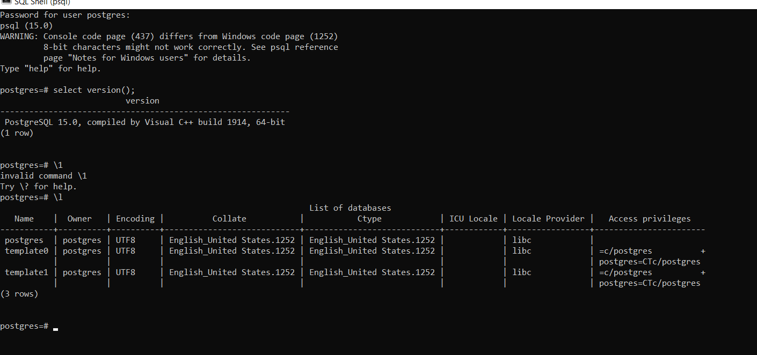

**Coding:**

Server [localhost]:

Database [postgres]:

Port [5432]:

Username [postgres]:

Password for user postgres:

psql (15.0)

WARNING: Console code page (437) differs from Windows code page (1252)

8-bit characters might not work correctly. See psql reference

page "Notes for Windows users" for details.

Type "help" for help.

postgres=# select version();

version

------------------------------------------------------------

PostgreSQL 15.0, compiled by Visual C++ build 1914, 64-bit

(1 row)

postgres=# \1

invalid command \1

Try \? for help.

postgres=# \l

List of databases

Name | Owner | Encoding | Collate | Ctype | ICU Locale | Locale Provider | Access privileges

-----------+----------+----------+----------------------------+----------------------------+------------+-----------------+-----------------------

postgres | postgres | UTF8 | English_United States.1252 | English_United States.1252 | | libc |

template0 | postgres | UTF8 | English_United States.1252 | English_United States.1252 | | libc | =c/postgres +

| | | | | | | postgres=CTc/postgres

template1 | postgres | UTF8 | English_United States.1252 | English_United States.1252 | | libc | =c/postgres +

| | | | | | | postgres=CTc/postgres

(3 rows)

postgres=# create database HR

postgres-# \l

List of databases

Name | Owner | Encoding | Collate | Ctype | ICU Locale | Locale Provider | Access privileges

-----------+----------+----------+----------------------------+----------------------------+------------+-----------------+-----------------------

postgres | postgres | UTF8 | English_United States.1252 | English_United States.1252 | | libc |

template0 | postgres | UTF8 | English_United States.1252 | English_United States.1252 | | libc | =c/postgres +

| | | | | | | postgres=CTc/postgres

template1 | postgres | UTF8 | English_United States.1252 | English_United States.1252 | | libc | =c/postgres +

| | | | | | | postgres=CTc/postgres

(3 rows)

postgres-# \HR

invalid command \HR

Try \? for help.

postgres-# \c HR

connection to server at "localhost" (::1), port 5432 failed: FATAL: database "HR" does not exist

Previous connection kept

postgres-# CREATE DATABASE HR

postgres-# \l

List of databases

Name | Owner | Encoding | Collate | Ctype | ICU Locale | Locale Provider | Access privileges

-----------+----------+----------+----------------------------+----------------------------+------------+-----------------+-----------------------

postgres | postgres | UTF8 | English_United States.1252 | English_United States.1252 | | libc |

template0 | postgres | UTF8 | English_United States.1252 | English_United States.1252 | | libc | =c/postgres +

| | | | | | | postgres=CTc/postgres

template1 | postgres | UTF8 | English_United States.1252 | English_United States.1252 | | libc | =c/postgres +

| | | | | | | postgres=CTc/postgres

(3 rows)

postgres-# \c HR

connection to server at "localhost" (::1), port 5432 failed: FATAL: database "HR" does not exist

Previous connection kept

postgres-# \c HR

You are now connected to database "HR" as user "postgres".

HR-# CREATE TABLE IF NOT EXISTS person (

HR(# Id INT PRIMARY KEY,

HR(# first_name VARCHAR(50) NOT NULL,

HR(# last_name VARCHAR(50) NOT NULL,

HR(# gender CHAR(1),

HR(# birthdate DATE,

HR(# email_id VARCHAR(100) UNIQUE,

HR(# country_of_birth VARCHAR(50)

HR(# );

ERROR: syntax error at or near "CREATE"

LINE 2: CREATE DATABASE HR

^

HR=# CREATE TABLE IF NOT EXISTS person (

HR(# Id INT PRIMARY KEY,

HR(# first_name VARCHAR(50) NOT NULL,

HR(# last_name VARCHAR(50) NOT NULL,

HR(# gender CHAR(1),

HR(# birthdate DATE,

HR(# email_id VARCHAR(100) UNIQUE,

HR(# country_of_birth VARCHAR(50)

HR(# );

CREATE TABLE

HR=# \d

List of relations

Schema | Name | Type | Owner

--------+--------+-------+----------

public | person | table | postgres

(1 row)

HR=# \d person

Table "public.person"

Column | Type | Collation | Nullable | Default

------------------+------------------------+-----------+----------+---------

id | integer | | not null |

first_name | character varying(50) | | not null |

last_name | character varying(50) | | not null |

gender | character(1) | | |

birthdate | date | | |

email_id | character varying(100) | | |

country_of_birth | character varying(50) | | |

Indexes:

"person_pkey" PRIMARY KEY, btree (id)

"person_email_id_key" UNIQUE CONSTRAINT, btree (email_id)

HR=#

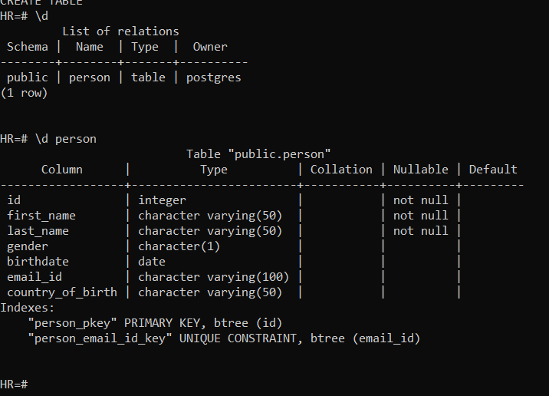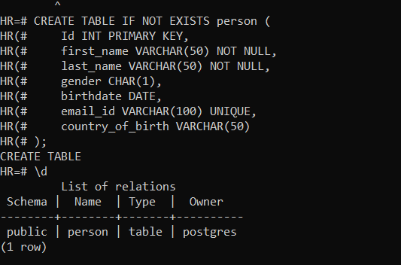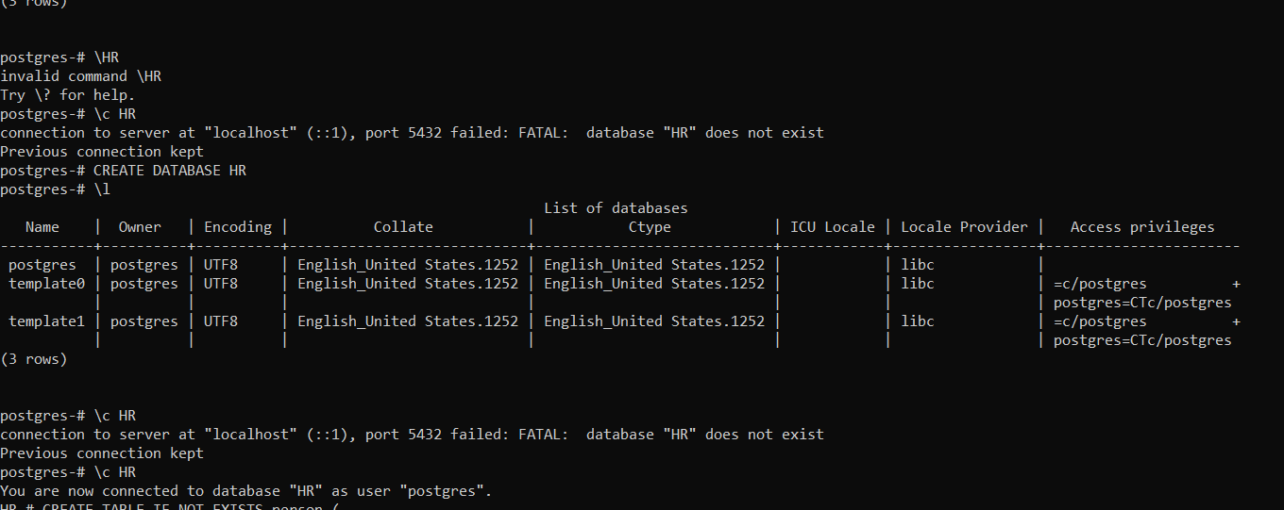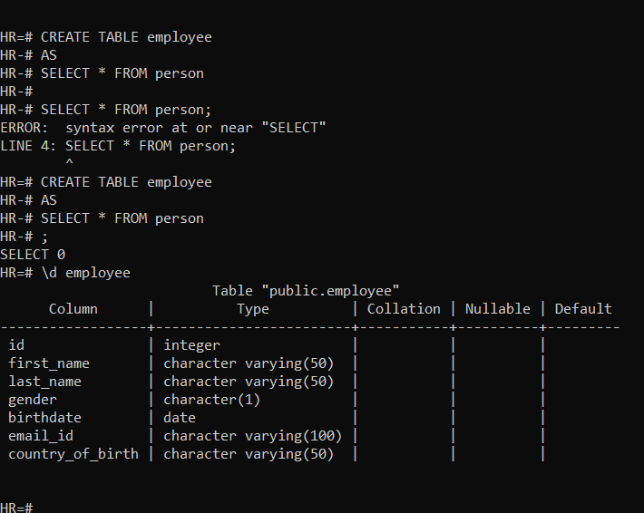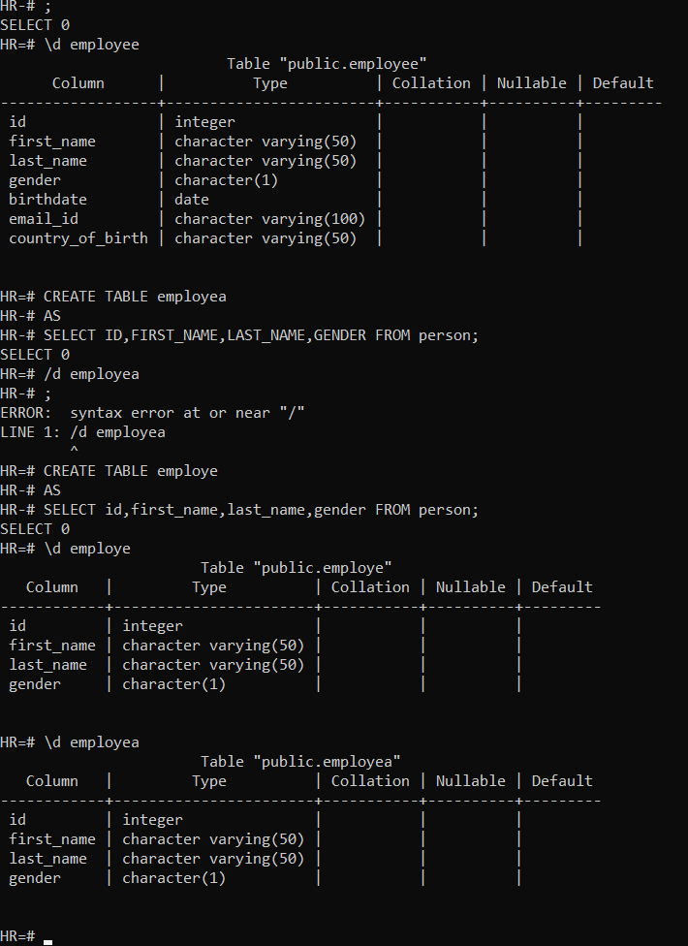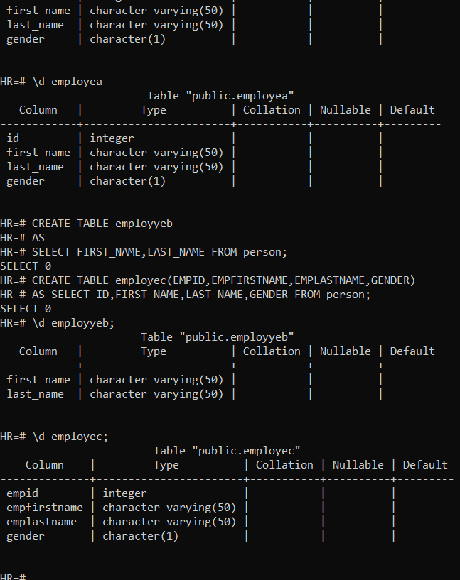

\HR

invalid command \HR

Try \? for help.

postgres-# \c HR

connection to server at "localhost" (::1), port 5432 failed: FATAL: database "HR" does not exist

Previous connection kept

postgres-# CREATE DATABASE HR

postgres-# \l

List of databases

Name | Owner | Encoding | Collate | Ctype | ICU Locale | Locale Provider | Access privileges

-----------+----------+----------+----------------------------+----------------------------+------------+-----------------+-----------------------

postgres | postgres | UTF8 | English_United States.1252 | English_United States.1252 | | libc |

template0 | postgres | UTF8 | English_United States.1252 | English_United States.1252 | | libc | =c/postgres +

| | | | | | | postgres=CTc/postgres

template1 | postgres | UTF8 | English_United States.1252 | English_United States.1252 | | libc | =c/postgres +

| | | | | | | postgres=CTc/postgres

(3 rows)

postgres-# \c HR

connection to server at "localhost" (::1), port 5432 failed: FATAL: database "HR" does not exist

Previous connection kept

postgres-# \c HR

You are now connected to database "HR" as user "postgres".

HR-# CREATE TABLE IF NOT EXISTS person (

HR(# Id INT PRIMARY KEY,

HR(# first_name VARCHAR(50) NOT NULL,

HR(# last_name VARCHAR(50) NOT NULL,

HR(# gender CHAR(1),

HR(# birthdate DATE,

HR(# email_id VARCHAR(100) UNIQUE,

HR(# country_of_birth VARCHAR(50)

HR(# );

ERROR: syntax error at or near "CREATE"

LINE 2: CREATE DATABASE HR

^

HR=# CREATE TABLE IF NOT EXISTS person (

HR(# Id INT PRIMARY KEY,

HR(# first_name VARCHAR(50) NOT NULL,

HR(# last_name VARCHAR(50) NOT NULL,

HR(# gender CHAR(1),

HR(# birthdate DATE,

HR(# email_id VARCHAR(100) UNIQUE,

HR(# country_of_birth VARCHAR(50)

HR(# );

CREATE TABLE

HR=# \d

List of relations

Schema | Name | Type | Owner

--------+--------+-------+----------

public | person | table | postgres

(1 row)

HR=# \d person

Table "public.person"

Column | Type | Collation | Nullable | Default

------------------+------------------------+-----------+----------+---------

id | integer | | not null |

first_name | character varying(50) | | not null |

last_name | character varying(50) | | not null |

gender | character(1) | | |

birthdate | date | | |

email_id | character varying(100) | | |

country_of_birth | character varying(50) | | |

Indexes:

"person_pkey" PRIMARY KEY, btree (id)

"person_email_id_key" UNIQUE CONSTRAINT, btree (email_id)

HR=# CREATE TABLE employee

HR-# AS

HR-# SELECT * FROM person

HR-#

HR-# SELECT * FROM person;

ERROR: syntax error at or near "SELECT"

LINE 4: SELECT * FROM person;

^

HR=# CREATE TABLE employee

HR-# AS

HR-# SELECT * FROM person

HR-# ;

SELECT 0

HR=# \d employee

Table "public.employee"

Column | Type | Collation | Nullable | Default

------------------+------------------------+-----------+----------+---------

id | integer | | |

first_name | character varying(50) | | |

last_name | character varying(50) | | |

gender | character(1) | | |

birthdate | date | | |

email_id | character varying(100) | | |

country_of_birth | character varying(50) | | |

HR=# CREATE TABLE employea

HR-# AS

HR-# SELECT ID,FIRST_NAME,LAST_NAME,GENDER FROM person;

SELECT 0

HR=# /d employea

HR-# ;

ERROR: syntax error at or near "/"

LINE 1: /d employea

^

HR=# CREATE TABLE employe

HR-# AS

HR-# SELECT id,first_name,last_name,gender FROM person;

SELECT 0

HR=# \d employe

Table "public.employe"

Column | Type | Collation | Nullable | Default

------------+-----------------------+-----------+----------+---------

id | integer | | |

first_name | character varying(50) | | |

last_name | character varying(50) | | |

gender | character(1) | | |

HR=# \d employea

Table "public.employea"

Column | Type | Collation | Nullable | Default

------------+-----------------------+-----------+----------+---------

id | integer | | |

first_name | character varying(50) | | |

last_name | character varying(50) | | |

gender | character(1) | | |

HR=# CREATE TABLE employyeb

HR-# AS

HR-# SELECT FIRST_NAME,LAST_NAME FROM person;

SELECT 0

HR=# CREATE TABLE employec(EMPID,EMPFIRSTNAME,EMPLASTNAME,GENDER)

HR-# AS SELECT ID,FIRST_NAME,LAST_NAME,GENDER FROM person;

SELECT 0

HR=# \d employyeb;

Table "public.employyeb"

Column | Type | Collation | Nullable | Default

------------+-----------------------+-----------+----------+---------

first_name | character varying(50) | | |

last_name | character varying(50) | | |

HR=# \d employec;

Table "public.employec"

Column | Type | Collation | Nullable | Default

--------------+-----------------------+-----------+----------+---------

empid | integer | | |

empfirstname | character varying(50) | | |

emplastname | character varying(50) | | |

gender | character(1) | | |

HR=# CREATE TEMPORARY TABLE IF NOT EXISTS mytemptable(Id INT ,Name VARCHAR(50));

CREATE TABLE

HR=# DROP TABLE IF EXISTS employyeb;

DROP TABLE

HR=# CREATE TABLE employeed

HR-# (emp_id int primary key,first_name varchar(50),last_name varchar(50)

HR(# ,gender char(1),dept_id int not null, foreign key (dept_id) references department (dept_id));

ERROR: relation "department" does not exist

HR=# create table department(dept_id int primary key,dept_name varchar(100) not null);

CREATE TABLE

HR=# create table employeed(emp_id int primary key,first_name varchar(50) not null,

HR(# last_name varchar(50) not null,gender char(1),dept_id int not null,

HR(# foreign key (dept_id) references department(dept_id));

CREATE TABLE

HR=# \d employeed;

Table "public.employeed"

Column | Type | Collation | Nullable | Default

------------+-----------------------+-----------+----------+---------

emp_id | integer | | not null |

first_name | character varying(50) | | not null |

last_name | character varying(50) | | not null |

gender | character(1) | | |

dept_id | integer | | not null |

Indexes:

"employeed_pkey" PRIMARY KEY, btree (emp_id)

Foreign-key constraints:

"employeed_dept_id_fkey" FOREIGN KEY (dept_id) REFERENCES department(dept_id)

HR=# drop table if exists employeed;

DROP TABLE

HR=# drop table if exists department;

DROP TABLE

HR=# CREATE TABLE employee(

HR(# emp_id INT PRIMARY KEY,

HR(# first_name VARCHAR(50) NOT NULL,

HR(# last_name VARCHAR(50) NOT NULL,

HR(# gender CHAR(1),

HR(# dept_id INT NOT NULL,

HR(#

HR(# FOREIGN KEY (dept_id) REFERENCES department(dept_id)

HR(# );

ERROR: relation "employee" already exists

HR=#

HR=# CREATE TABLE department (

HR(# dept_id INT PRIMARY KEY,

HR(# dept_name VARCHAR(100) NOT NULL

HR(# );

CREATE TABLE

HR=#

PostgreSQL supports the ALTER TABLE statement to modify the structure of the existing tables.

ALTER table can be used to

1. Add column
2. Rename column
3. Modify column datatype
4. Set or Remove default value to column
5. Add or Drop constraint to column
6. Drop column in the table

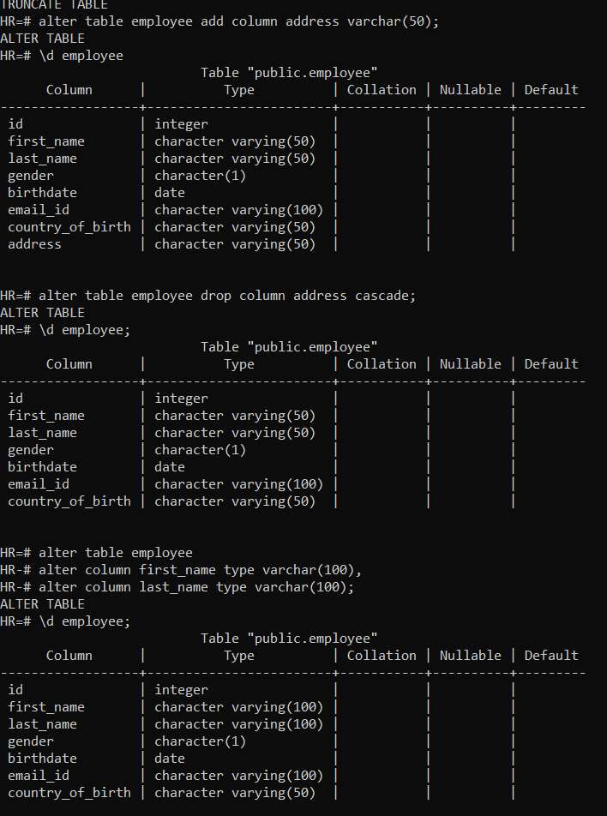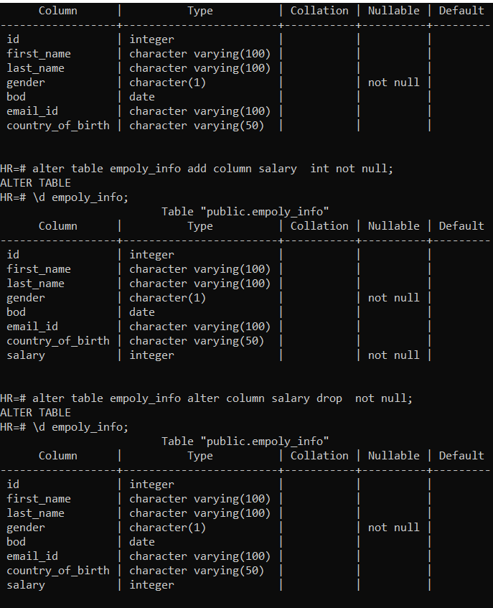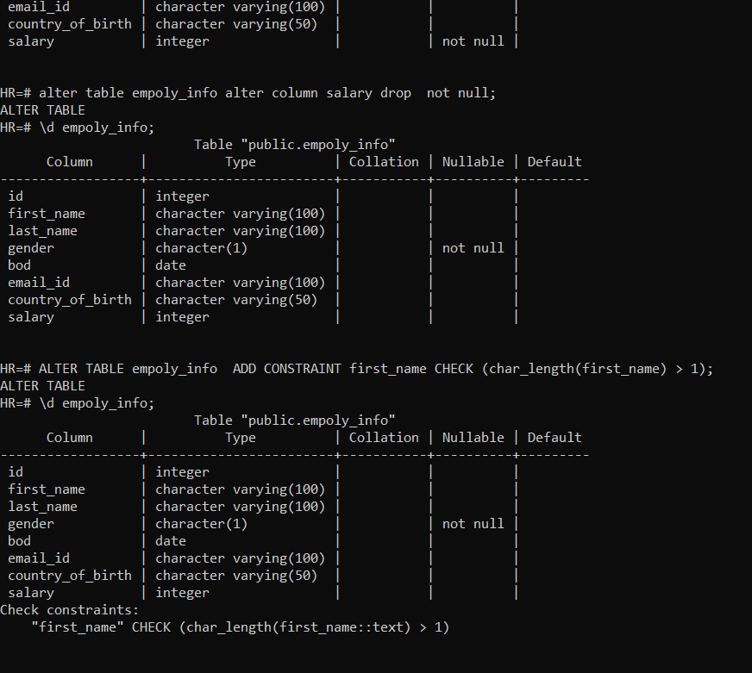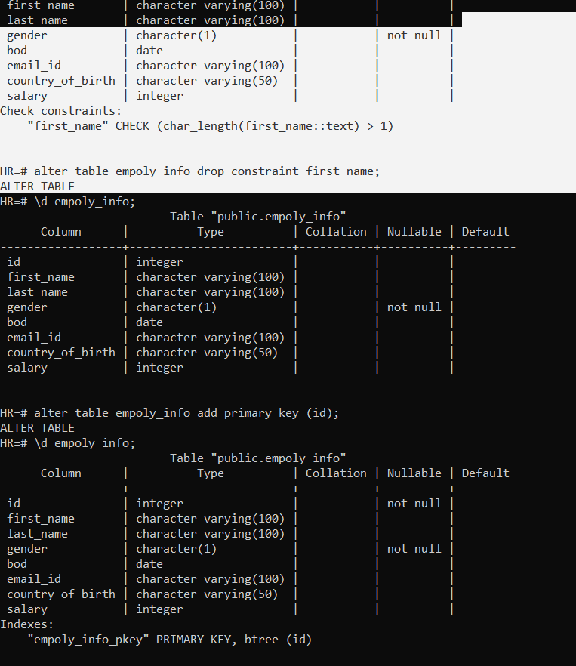

HR=# alter table employee drop column address cascade;

ALTER TABLE

HR=# \d employee;

Table "public.employee"

Column | Type | Collation | Nullable | Default

------------------+------------------------+-----------+----------+---------

id | integer | | |

first_name | character varying(50) | | |

last_name | character varying(50) | | |

gender | character(1) | | |

birthdate | date | | |

email_id | character varying(100) | | |

country_of_birth | character varying(50) | | |

HR=# alter table employee

HR-# alter column first_name type varchar(100),

HR-# alter column last_name type varchar(100);

ALTER TABLE

HR=# \d employee;

Table "public.employee"

Column | Type | Collation | Nullable | Default

------------------+------------------------+-----------+----------+---------

id | integer | | |

first_name | character varying(100) | | |

last_name | character varying(100) | | |

gender | character(1) | | |

birthdate | date | | |

email_id | character varying(100) | | |

country_of_birth | character varying(50) | | |

HR=# alter table employee rename column birthdate to BOD;

ALTER TABLE

HR=# \d employee;

Table "public.employee"

Column | Type | Collation | Nullable | Default

------------------+------------------------+-----------+----------+---------

id | integer | | |

first_name | character varying(100) | | |

last_name | character varying(100) | | |

gender | character(1) | | |

bod | date | | |

email_id | character varying(100) | | |

country_of_birth | character varying(50) | | |

HR=# alter table employee rename to empoly_info;

ALTER TABLE

HR=# \d employ_info;

Did not find any relation named "employ_info".

HR=# \d empoly_info;

Table "public.empoly_info"

Column | Type | Collation | Nullable | Default

------------------+------------------------+-----------+----------+---------

id | integer | | |

first_name | character varying(100) | | |

last_name | character varying(100) | | |

gender | character(1) | | |

bod | date | | |

email_id | character varying(100) | | |

country_of_birth | character varying(50) | | |

HR=# alter table empoly_info alter column gender set not null;

ALTER TABLE

HR=# \d empoly_info;

Table "public.empoly_info"

Column | Type | Collation | Nullable | Default

------------------+------------------------+-----------+----------+---------

id | integer | | |

first_name | character varying(100) | | |

last_name | character varying(100) | | |

gender | character(1) | | not null |

bod | date | | |

email_id | character varying(100) | | |

country_of_birth | character varying(50) | | |

HR=# alter table empoly_info add column salary int not null;

ALTER TABLE

HR=# \d empoly_info;

Table "public.empoly_info"

Column | Type | Collation | Nullable | Default

------------------+------------------------+-----------+----------+---------

id | integer | | |

first_name | character varying(100) | | |

last_name | character varying(100) | | |

gender | character(1) | | not null |

bod | date | | |

email_id | character varying(100) | | |

country_of_birth | character varying(50) | | |

salary | integer | | not null |

HR=# alter table empoly_info alter column salary drop not null;

ALTER TABLE

HR=# \d empoly_info;

Table "public.empoly_info"

Column | Type | Collation | Nullable | Default

------------------+------------------------+-----------+----------+---------

id | integer | | |

first_name | character varying(100) | | |

last_name | character varying(100) | | |

gender | character(1) | | not null |

bod | date | | |

email_id | character varying(100) | | |

country_of_birth | character varying(50) | | |

salary | integer | | |

HR=# ALTER TABLE empoly_info ADD CONSTRAINT first_name CHECK (char_length(first_name) > 1);

ALTER TABLE

HR=# \d empoly_info;

Table "public.empoly_info"

Column | Type | Collation | Nullable | Default

------------------+------------------------+-----------+----------+---------

id | integer | | |

first_name | character varying(100) | | |

last_name | character varying(100) | | |

gender | character(1) | | not null |

bod | date | | |

email_id | character varying(100) | | |

country_of_birth | character varying(50) | | |

salary | integer | | |

Check constraints:

"first_name" CHECK (char_length(first_name::text) > 1)

HR=# alter table empoly_info drop constraint first_name;

ALTER TABLE

HR=# \d empoly_info;

Table "public.empoly_info"

Column | Type | Collation | Nullable | Default

------------------+------------------------+-----------+----------+---------

id | integer | | |

first_name | character varying(100) | | |

last_name | character varying(100) | | |

gender | character(1) | | not null |

bod | date | | |

email_id | character varying(100) | | |

country_of_birth | character varying(50) | | |

salary | integer | | |

HR=# alter table empoly_info add primary key (id);

ALTER TABLE

HR=# \d empoly_info;

Table "public.empoly_info"

Column | Type | Collation | Nullable | Default

------------------+------------------------+-----------+----------+---------

id | integer | | not null |

first_name | character varying(100) | | |

last_name | character varying(100) | | |

gender | character(1) | | not null |

bod | date | | |

email_id | character varying(100) | | |

country_of_birth | character varying(50) | | |

salary | integer | | |

Indexes:

"empoly_info_pkey" PRIMARY KEY, btree (id)